**SVKM’s NMIMS**

**Mukesh Patel School of Technology Management & Engineering**

**Computer Engineering Department**

**Program: B.Tech. Computer Engineering, Sem VI**

**Course: Business Visualization and Analysis**



**Countries Dataset Dashboard Report**

**By**

**Kanika Nadar (B050)**

**Khushi Shah (B067)**

**Under the guidance of,**

**Prof. Mahesh Mali**

**Chapter 1**

# Problem statement

## ****Objective:****

To categorise the countries using GDP, Class, Socio-economic status and Years of Education to determine the overall development of the country and their socio-financial footing.

## ****About organization:****

HELP International is an international humanitarian NGO that is committed to fighting poverty, illiteracy and providing the people of backward countries with basic amenities, financial aid and primary education so as to uplift the country.

## ****Problem Statement:****

HELP International have been able to raise around $10 million. Now the CEO of the NGO needs to decide how to use this money strategically and effectively. So, the CEO has to make decision to choose the countries and regions that are in need of assistance. Hence, your Job as a Data scientist is to categorise the countries based on GDP, Socio-economic status, Years of Education and Class factors that determine the overall development of the country. Then you need to suggest the countries which the CEO needs to focus on the most.

**Chapter 2**

# Dataset description

The chosen dataset is the COUNTRIES dataset from SAS Viya for Learners. It has 11 columns and 888 rows.

The variables are:

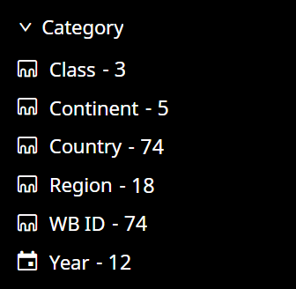

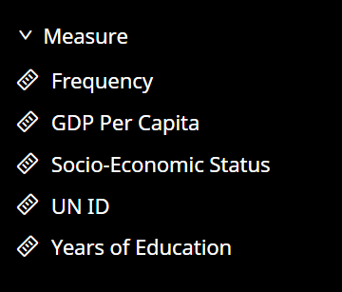

**Chapter 3**

# Dashboard design process manual

The dashboard design process in SAS Viya for learners typically involves the following steps:

1. **Data Preparation**: The first step in designing a dashboard is to identify the data sources that will be used to create the dashboard. In SAS Viya, we can use data from various sources such as SAS data sets, databases, spreadsheets, and other sources. We need to identify the data elements that will be used in the dashboard and ensure that the data is clean and accurate.
2. **Dashboard Planning**: Once we have identified the data elements, we need to plan the layout and design of the dashboard. You should consider the target audience and the purpose of the dashboard when planning its layout. The dashboard should be easy to read and understand and should highlight the most important information.
3. **Building the Dashboard**: After planning the dashboard, you can start building it using the SAS Visual Analytics Designer. This tool allows you to drag and drop data elements onto the dashboard and create visualizations such as charts, graphs, and tables.
4. **Testing and Validation**: Once the dashboard has been built, you should test and validate it to ensure that it meets the requirements and objectives that were established during the planning phase. You should also ensure that the data is accurate and that the visualizations are easy to read and understand.
5. **Deployment and Maintenance**: After testing and validation, the dashboard can be deployed to end-users. You should also ensure that the dashboard is maintained and updated regularly to ensure that it continues to meet the needs of the users.

Overall, the dashboard design process in SAS Viya for learners involves a combination of data preparation, planning, building, testing, deployment, and maintenance to create effective and useful dashboards for decision-making.

**Chapter 4**

# Output

## Report level control:

* One **report level control** has been added in the form of **button bar**. It is based on the continents variable.

## 

## Page 1

* The **page controls** we used were **slider** and **drop-down**.
* The slider is used to focus on the GDP of a specific range of years.
* The drop-down menu helps us in selecting a specific country to be analyzed for its GDP.

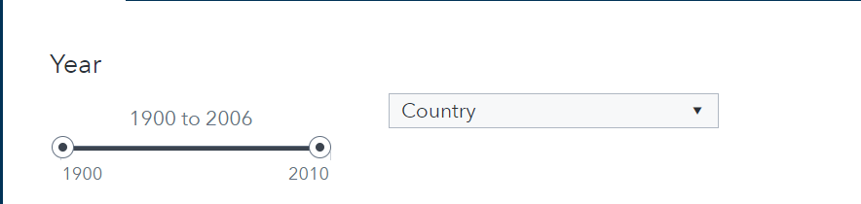

* The **Geomap by Region** shows the GDP per Capita by Country over a world map.
* A Darker shade of blue indicates higher GDP while a lighter shade of blue indicates lower GDP.
* The slider can be used to observe the GDP of the countries for a specific range of years.
* The drop-down can be used to observe the location and the intensity of GDP of a specific country on the map.
* The geomap has been linked to page 2 using page links. By clicking on a country on the geomap, the graphs on page 2 reflect results only for that particular country.
* **Inference**: North America, Western Europe and Australia have a higher GDP as compared to Africa, India and South - East Asian countries. On moving the slider, it is observed that the intensities on the map did not change much. This implies that the countries haven’t overtaken each other much in terms of GDP over the years.

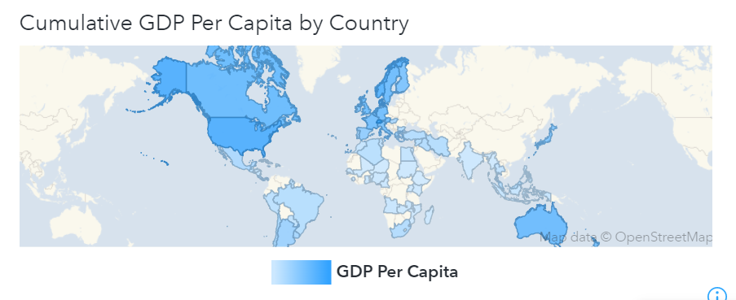

* Below is a **line graph** with GDP per Capita by Year (in millions) in the y-axis and the year in the x-axis.
* The slider can be used to observe the growth in GDP over the course of a specific range of years.
* The drop-down menu along with the slider can be used to observe the trend of GDP for a particular country within a particular span of years.
* **Inference**: Worldwide, from the year 1900 to the year 2006, the GDP has been growing. There was a sharp increase from 1980 onwards and the same is true when we tune the chart to reflect the data of specific countries.

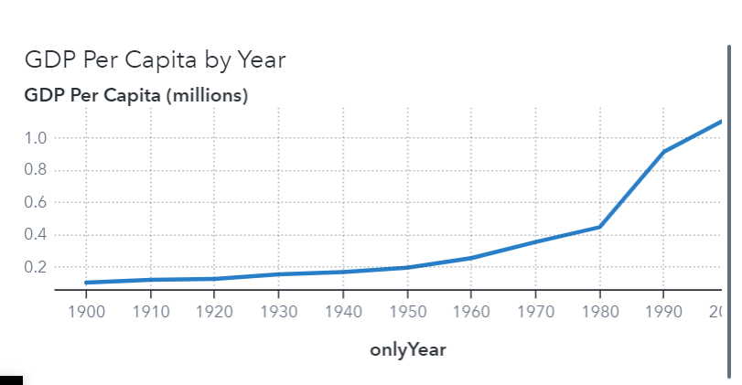

## Page 2

* The **butterfly chart** has Socio – economic status in the left half of the x – axis and the Years of Education in the right – half of the x – axis.
* The y – axis plots the above parameters by Years.
* The socio – economic status has relatively stayed the same for all countries except for a high in the year 1930. This was probably because of the “high” right before the Great Depression.
* The rate of education however, has consistently been increasing, albeit at a slower pace.

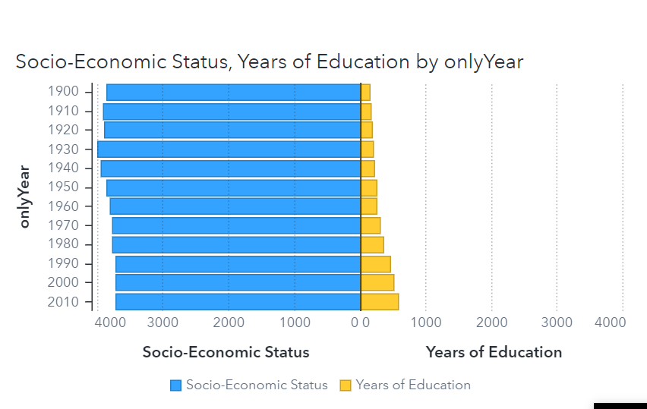

* The **line graph** below plots the GDP per Capita (in millions) over the years in blue and the Years of Education over the Years in Yellow.
* This graph compares the rate of growth of GDP and the Years of Education over the Years
* Inference 1: GDP has had a higher rate of growth as compared to Years of Education. Moreover, there was a spike in the growth of GDP in the 1980s.
* Inference 2: Comparatively, Years of Education has a slow and steadier growth.

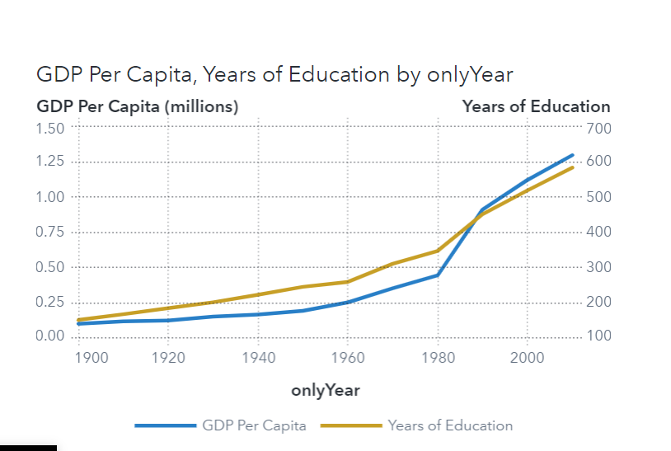

## Page 3

* Two **page level controls** were used here. A **text box** for Year and a **drop-down** for Region.



* The first graph on this page is a **pie chart**. The pie chart shows the frequency of countries by class.
* The pie chart has been linked to page 4 using page links.
* **Inference:** Highest percentage of countries fall in high class, followed by middle class, followed by poor class.

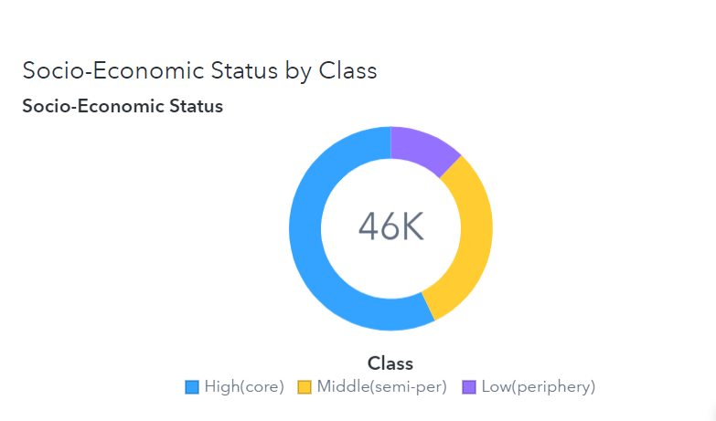

* Next we plotted a **bar graph.** X-axis: years, Y-axis: Years of Education, partitioned using class.
* **Inference:** Over the years, Years of education has increased for all classes. For all years high class has the most years of education, followed by middle class, followed by poor class.

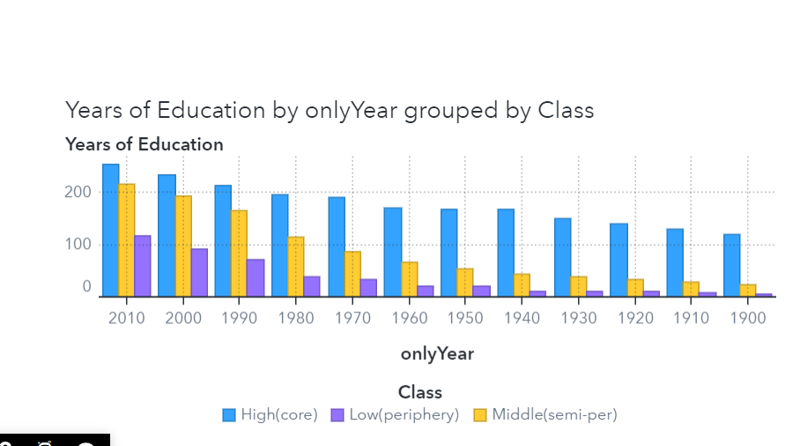

## Page 4

* There are two **butterfly graphs** on this place.
* For the first graph: Category- Region, Measure- GDP Per Capita, Lattice colums- Years.
* **Inference:** West Europe has highest level of education and highest GDP per capita consistently over the years. East Africa has lowest level of education and lowest GDP per capita over the years.

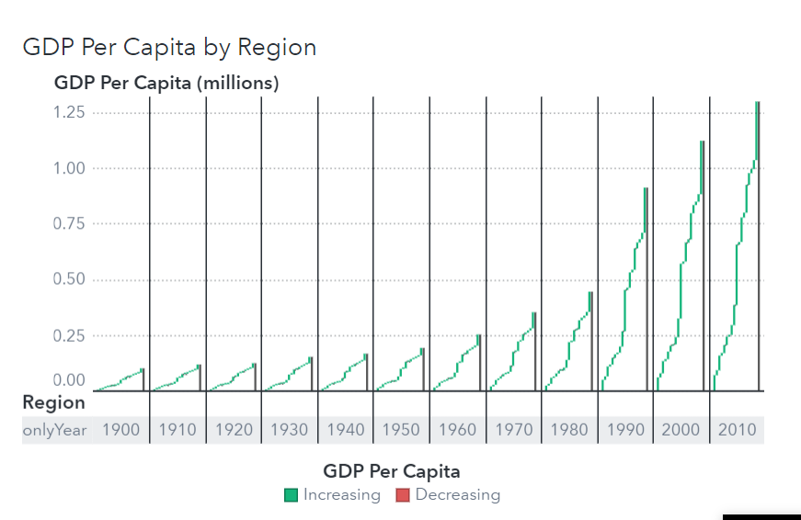

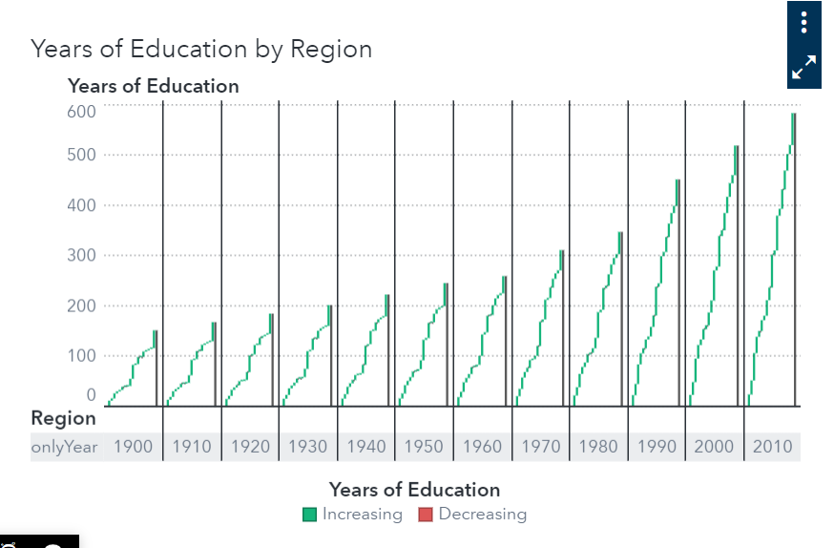

## Page 5

* We built a **decision tree** to analyze our dataset. The variable with the most importance is Years of Education. That is why it is the root node of our decision tree.

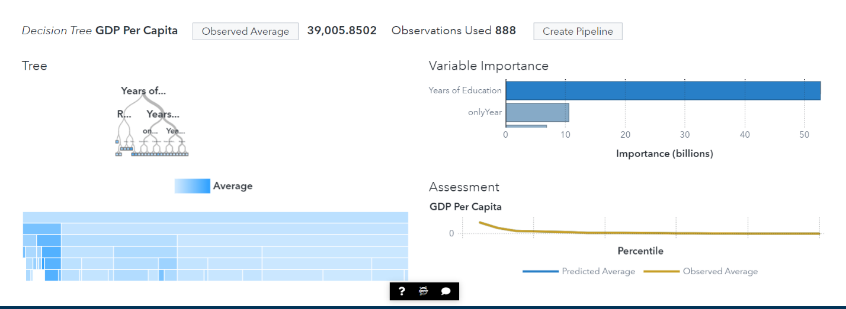

**Chapter 4**

# Learning Outcomes

* We can conclude that Education plays an important role in the socio-economic growth of a country.
* Hence, the CEO of Help International can invest money in providing education to the young generation of developing and underprivileged countries so as to aid in their overall growth and development.